Predicting Property Prices in a Specific Location
Using Machine Learning

- Introduction to the Project:

This project focuses on predicting property prices in a specific location using Machine Learning techniques. The real estate market is influenced by several factors such as location, property size, amenities, neighbourhood, and overall quality. Accurate price prediction helps buyers, sellers, and real estate professionals make informed decisions. In this project, various regression models are built and evaluated to identify the most effective approach.

- Objectives of the Project:
- To collect and clean real estate data from a specific location.
- To handle missing values, encode categorical variables appropriately and improve the accuracy.
- To perform Exploratory Data Analysis (EDA) to understand data patterns.
- To develop a machine learning model that can predict property prices based on the selected variables.
- To handle numerical, ordinal and nominal columns separately using encoding techniques.
- To build multiple machine learning models and do model training (Train/Test Split).
- To evaluate models using MAE and RMSE metrics.
- To develop a machine learning model that can predict property prices based on the selected variables.
- To present the findings and insights from the project in a clear and concise manner.

- Flow Chart of Operations:
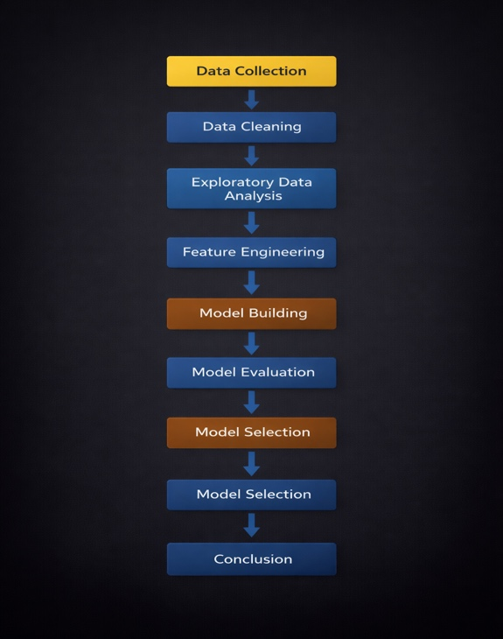

- Python Codes:

Python libraries used include Pandas, NumPy, Matplotlib, Seaborn, and Scikit-learn. The project code covers data preprocessing, EDA, model training, evaluation, and comparison.

- Screenshot of the Output:

Some additional columns through Feature Engineering:

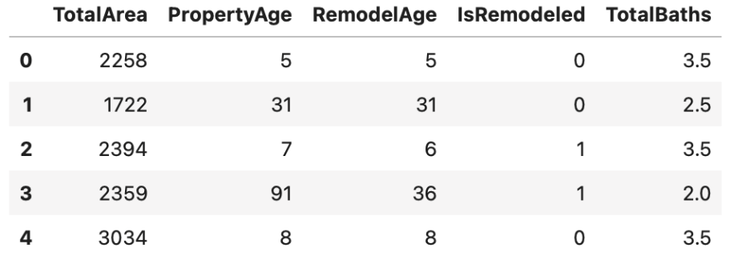

Model Comparison Output (MAE & RMSE):

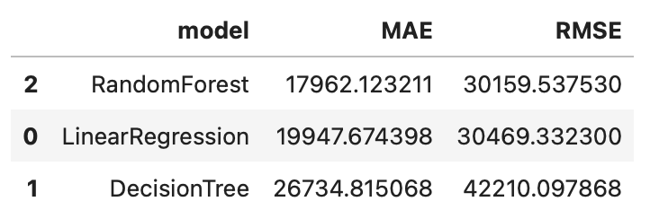

- Report on EDA:

For EDA, I’ve done univariate, bivariate and multivariate analysis. EDA revealed that property prices are right-skewed, indicating the presence of high-value luxury properties. Overall quality and living area show strong relationships with property prices. Several features contained missing values which represented the absence of facilities rather than data errors. I’ve also added some insights into the Jupyter notebook for better analysis and insights that I’ve come across while doing EDA on the dataset.

- Univariate Analysis:
Univariate Analysis on some major plots for important columns are as follows with insights-
- PropPrice -
Skewness: Strong right-skewed distributions.
Outliers: Presence of high-value luxury property outliers.
Insights: Most properties fall in the mid-price range, while a few premium properties significantly increase variability. Median price better represents the typical market value than mean.
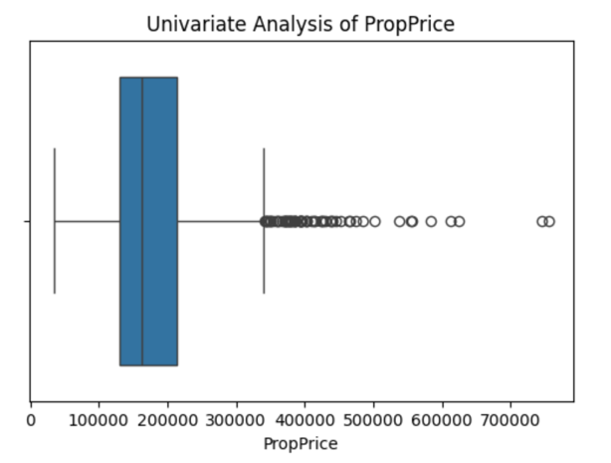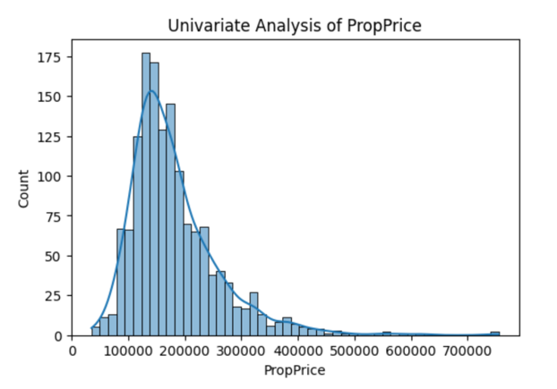

- GrLivArea –
Skewness: Right-skewed distributions.
Outliers: Few extremely large houses
Insights: Larger living areas generally lead to higher property prices, but oversized properties represent niche luxury demand.
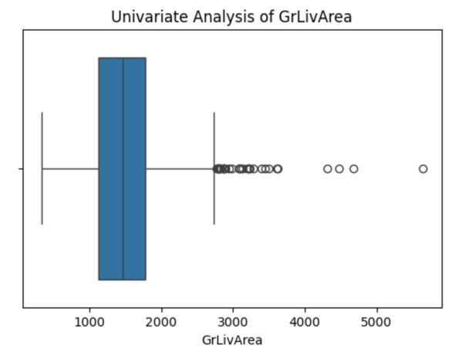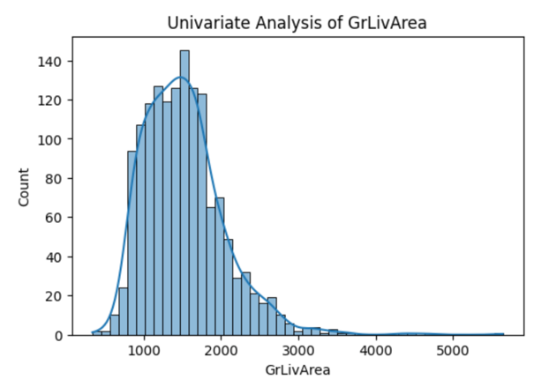

- OverallQual –
Skewness: Slight right-skew toward higher quality levels.
Outliers: Very few properties with extremely low or extremely high quality
Insights: Most properties are of average to good quality, making overall quality one of the strongest predictors of price.

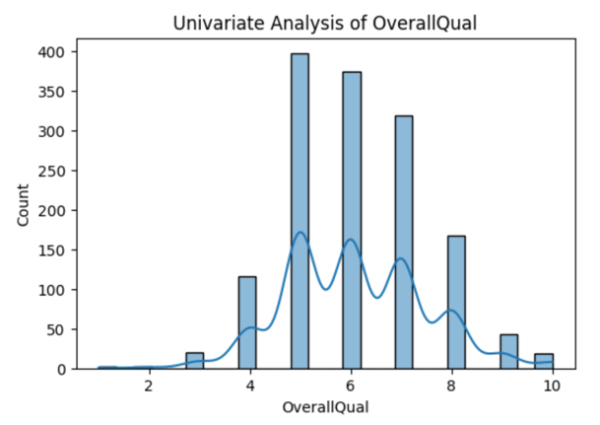

- Neighborhood –
Skewness: Imbalanced categorical distribution
Outliers: Certain neighborhoods appear very infrequently
Insight: Location significantly influences pricing, with some neighborhoods consistently commanding premium values.
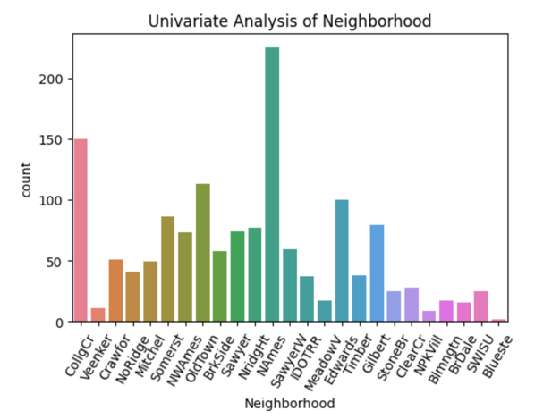

- PropertySize –
Skewness: Right-skewed distribution.
Outliers: Few extremely large plot sizes.
Insight: Larger plots increase property value, but marginal gains diminish beyond a certain size.
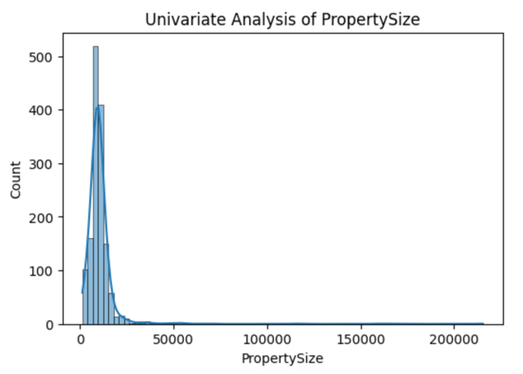

- YearBuilt –
Skewness: Slight right-skew (means more recent constructions).
Outliers: Few very old properties.
Insight: Newer homes dominate the dataset and generally have higher market value due to modern construction standards.
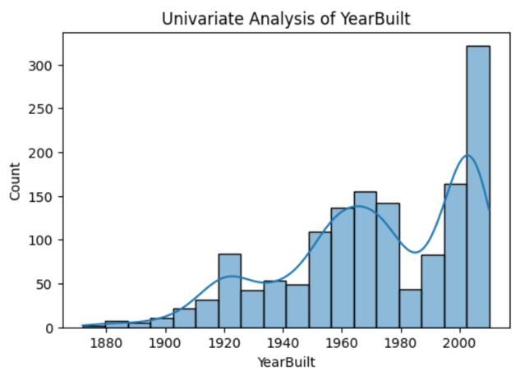

- KitchenQual –
Skewness: Concentration toward Average (TA) and Good (Gd) categories.
Outliers: Very few Poor or Excellent kitchens.
Insight: Kitchen quality is a critical interior feature that significantly affects buyer perception and price.
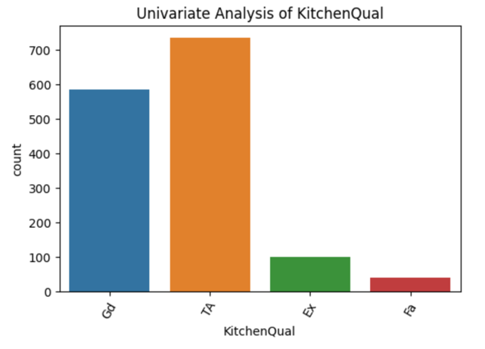

- BasementCars –
Skewness: Slight right-skew distribution.
Outliers: Few properties with unusually high parking capacity.
Insight: Parking availability increases desirability, though additional spaces beyond two provide diminishing returns.
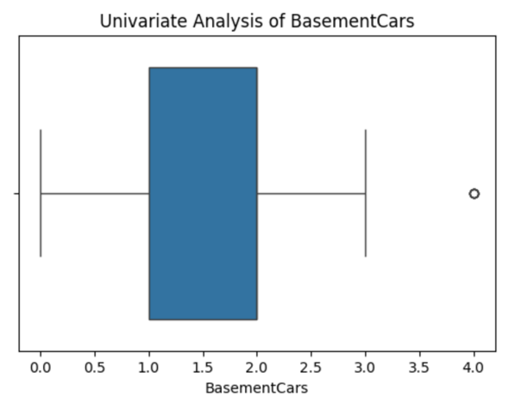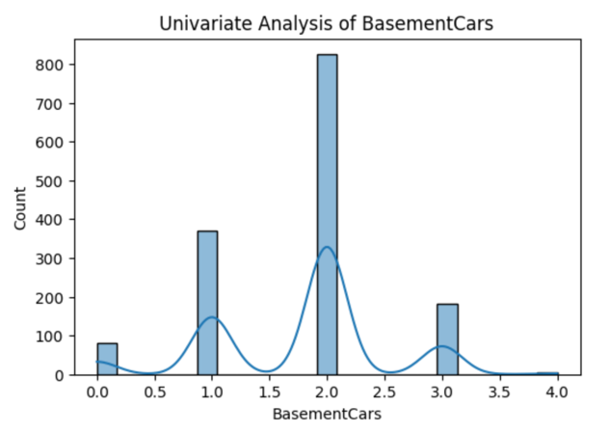

- BasementSqFootage –
Skewness: Right-skewed with many low values.
Outliers: Properties with very large basement areas.
Insight: Basement space adds functional value, but finished basements contribute more to pricing than unfinished space.
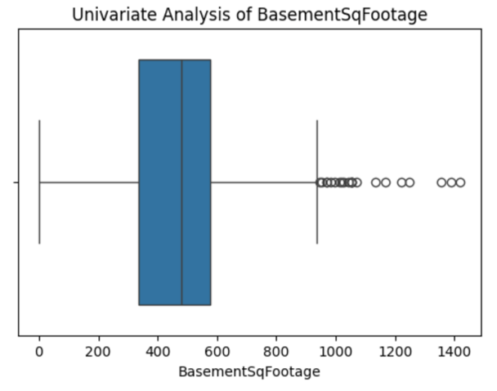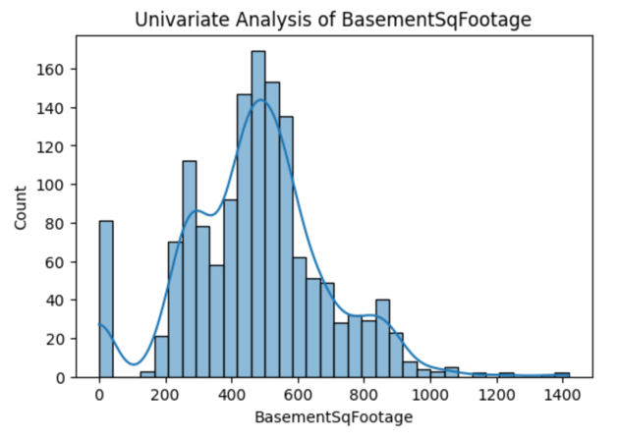

- CentralAir –
Skewness: Highly imbalanced categorical distribution (mostly “Yes”).
Outliers: Very few properties without central air.
Insight: Central air conditioning is a standard comfort feature and positively impacts property prices.
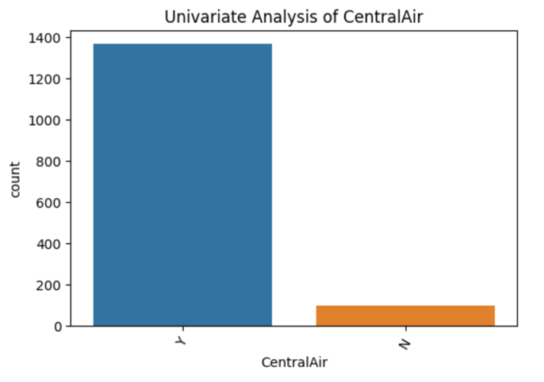

- Bivariate Analysis:

- GrLivArea vs PropPrice -
Insights: Here observed the clear upward trend more spread at higher values which shows that as the living area increases, property price increases significantly, indicating a strong positive correlation. Larger homes tend to command higher prices, though variability increases for luxury properties.
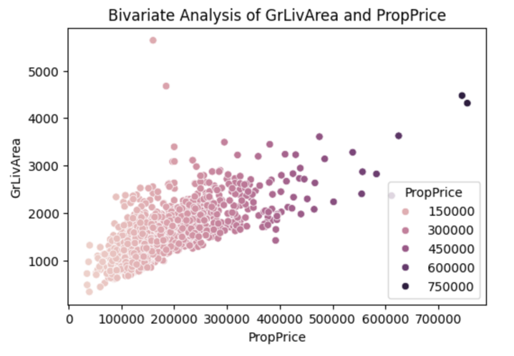

- OverallQual vs PropPrice -
Insights: Here observed that the median price rises steadily from low to high quality and Spread increases at higher quality levels which shows the properties with higher overall quality ratings consistently show higher median prices, confirming overall quality as one of the strongest determinants of property value.
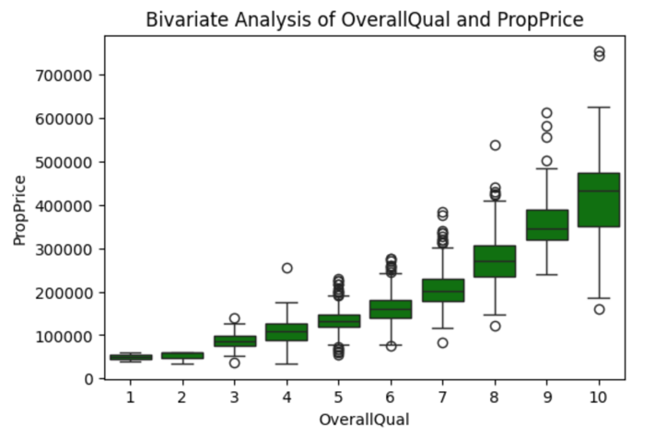

- Neighborhood vs PropPrice -
Insights: Here observed some neighborhoods have much higher medians and strong inter-neighborhood variation which shows the property prices vary significantly across neighborhoods, highlighting the importance of location in determining market value.
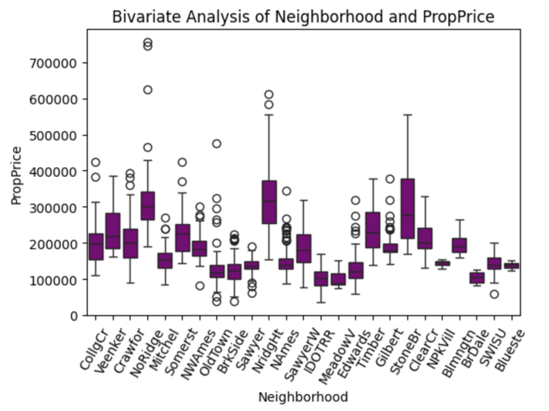

- YearBuilt vs PropPrice -
Insights: Here observed newer houses generally have higher prices some old houses still expensive which shows newer properties tend to sell at higher prices due to modern construction standards, though location and renovations allow some older homes to retain high value.
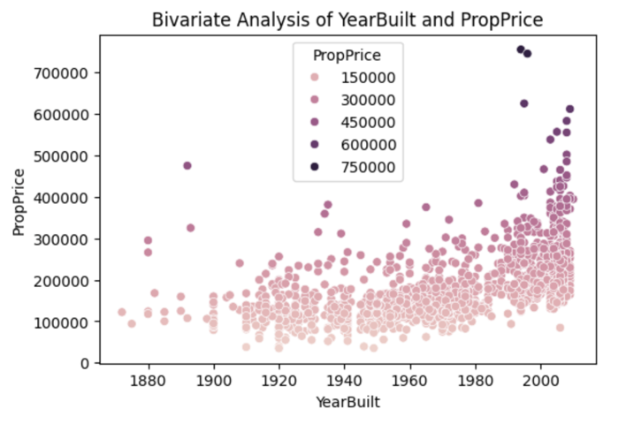

- KitchenQual vs PropPrice -
Insights: Here observed clear price jump from Average then Good and then Excellent and poor-quality kitchens are rare which shows kitchen quality strongly influences property price, with higher-quality kitchens associated with substantially higher median prices.
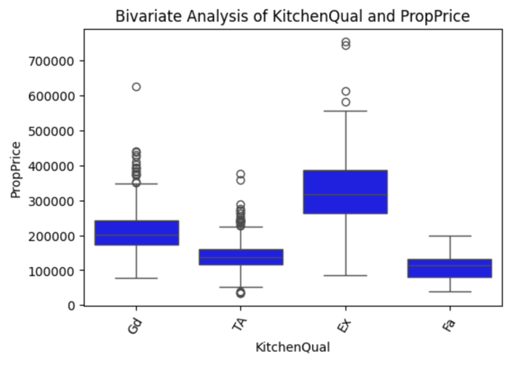

- BasementCars vs PropPrice -
Insights: Here observed prices rise with garage capacity and diminishing returns after 2–3 cars which shows the availability of parking positively impacts property prices, though additional spaces beyond standard capacity offer diminishing marginal value.
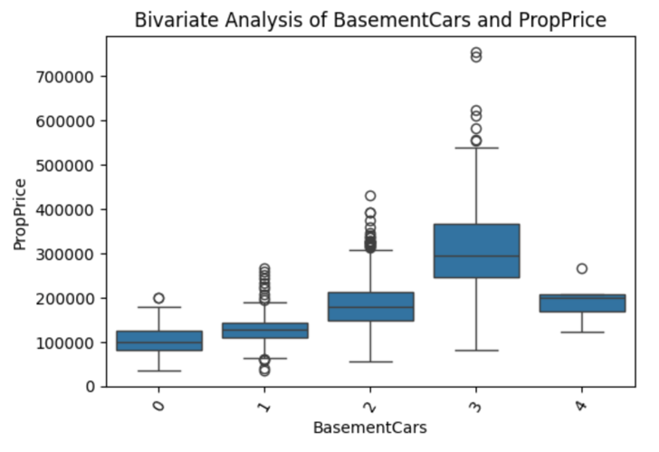

- CentralAir vs PropPrice -
Insights: Here observed Properties with central air have higher median prices which shows that the central air conditioning increases property desirability and is associated with higher sale prices.
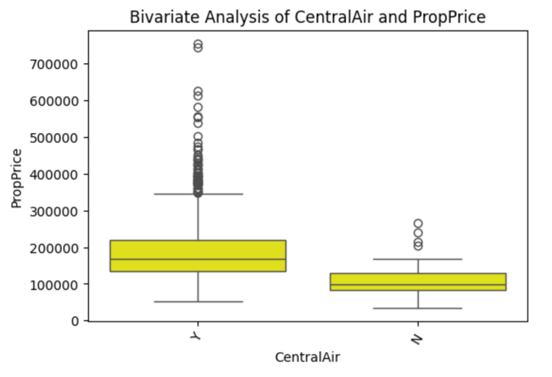

- SaleYr vs PropPrice -
Insights: Here observed the Overall upward movement with slight dips which shows that Property prices show temporal variation, reflecting broader market trends and economic conditions.
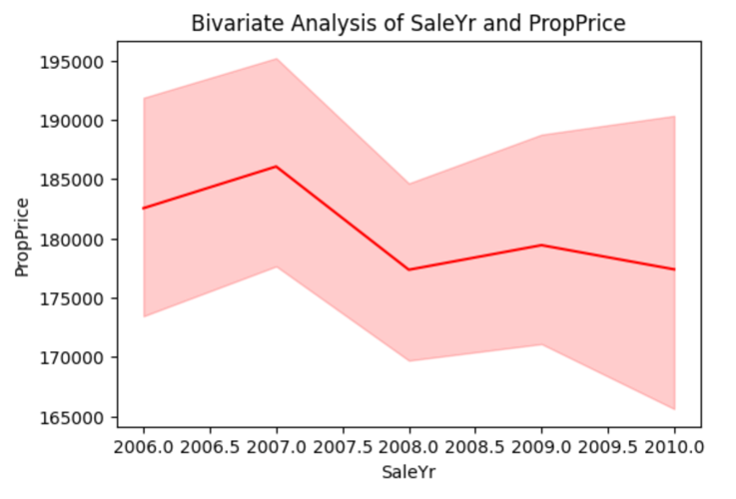

- GrLivArea vs OverallQual -
Insights: Here observed that the larger properties generally have higher quality ratings, though size and quality remain independent contributors to value.
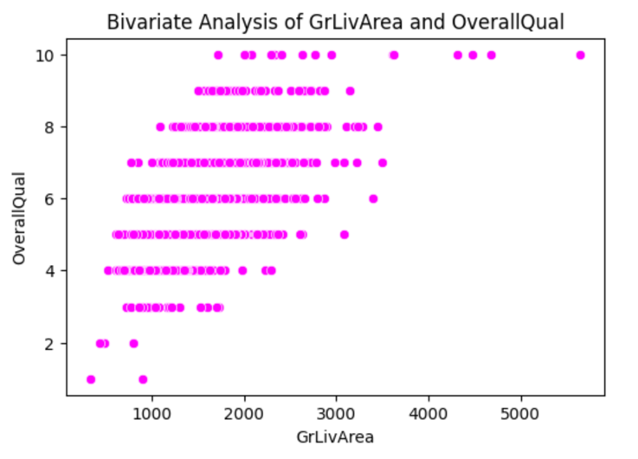

- BedroomUpLev vs GrLivArea -
Insights: Here observed that the houses with more bedrooms usually have larger living areas, but inefficient layouts exist where bedroom count does not scale proportionally with space.
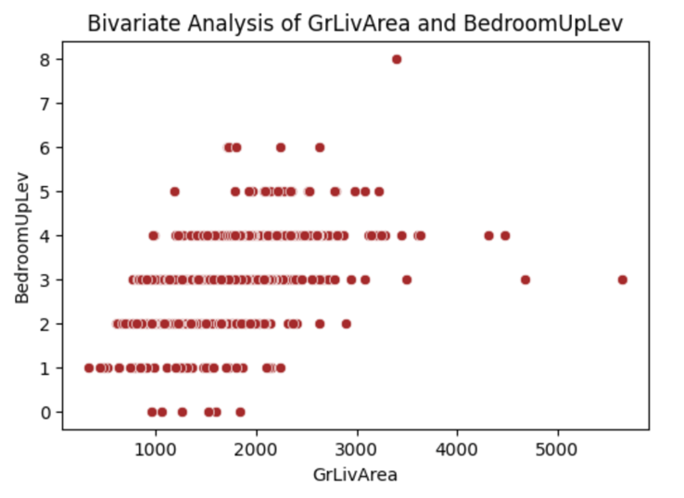

- KitchenQual vs OverallQual -
Insights: Here observed that the higher kitchen quality strongly aligns with higher overall quality, reinforcing kitchen quality as a proxy for construction standards.
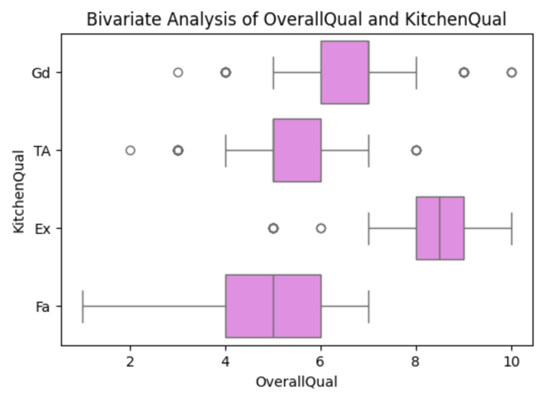

- Multivariate Analysis:

Insights:

Correlation Heatmap:
1. Shows pairwise linear relationships
2. Values range from –1 to +1
3. Helps detect redundant variables
Observations:
1. Strong Positive Correlations
2. GrLivArea ↔ 1stFlrSF
3. GrLivArea ↔ TotalArea
4. BasementSqFootage ↔ BasementCars
5. Bath1 ↔ CntRmsUpLev
Moderate Correlations
1. YearBuilt ↔ OverallQual
2. KitchenQual ↔ OverallQual
3. BedroomUpLev ↔ CntRmsUpLev
Weak Correlations
1. SaleMon with most features
2. LowQualFinSF with price-related variables
Interpretation:
The correlation heatmap reveals strong multicollinearity among size-related variables such as living area, floor area, and total area. Quality-related variables also show moderate correlation, indicating overlapping information content.

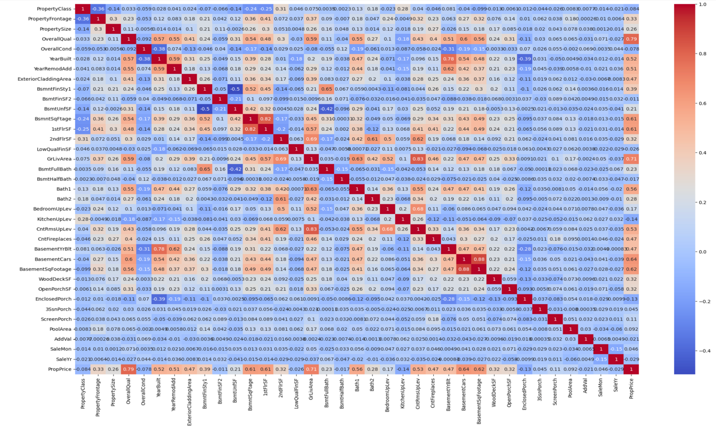

- Learning Outcomes:
- Understanding of real-world data preprocessing challenges.
- Hands-on experience with EDA techniques.
- Ability to apply regression algorithms for prediction tasks.
- Improved understanding of feature importance in real estate pricing.
- Practical knowledge of model evaluation techniques.

- Conclusion:
This project successfully developed a machine learning–based approach to predict property prices using structured real estate data. The analysis began with thorough data cleaning and preprocessing, where missing values, inconsistencies, and duplicates were handled carefully if present to maintain data quality. Exploratory Data Analysis (EDA) provided valuable insights into the dataset, revealing that property prices and size-related features are right-skewed and influenced by a small number of high-value properties, which is typical of real estate markets.
Univariate and bivariate analyses identified key factors affecting property prices, including living area, overall quality, neighborhood, and kitchen quality. Multivariate analysis using correlation heatmaps and Variance Inflation Factor (VIF) helped detect multicollinearity among related features, enabling effective feature selection and engineering. Derived features such as property age, total living area, and total bathrooms further improved the model’s ability to capture real-world pricing behaviour.
Several machine learning models were evaluated, including Linear Regression, Decision Tree, and Random Forest. Among them, the Random Forest model delivered the best performance due to its ability to model non-linear relationships and complex feature interactions, achieving reliable prediction accuracy measured using MAE and RMSE.
Overall, this project demonstrates that a structured data analysis pipeline combined with appropriate modeling techniques can effectively predict property prices. The insights and models developed in this study can support informed decision-making for buyers, sellers, and real estate professionals, and the approach can be extended with additional data or advanced models for future improvements.

- Citations:
https://www.datacamp.com/blog/data-preprocessing

https://www.geeksforgeeks.org/data-analysis/eda-with-numpy-pandas-matplotlib-seaborn/

https://seaborn.pydata.org/generated/seaborn.jointplot.html

https://pandas.pydata.org/docs/reference/index.html

https://www.geeksforgeeks.org/python/matplotlib-tutorial/

https://seaborn.pydata.org/api.html

https://scikit-learn.org/stable/

